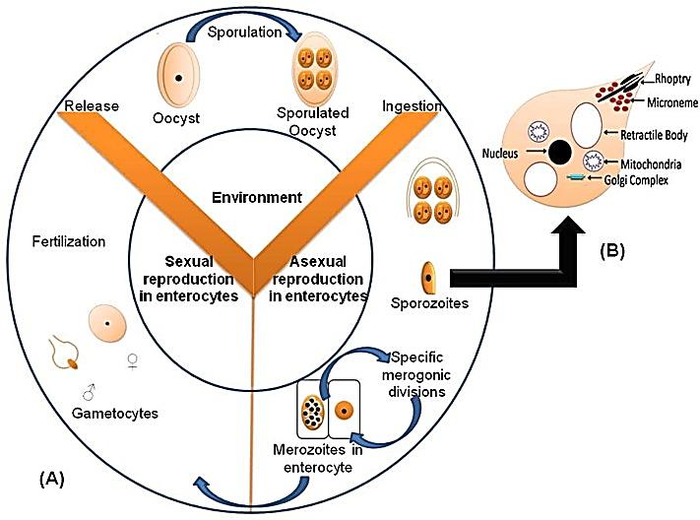
圖一、 (A) 艾美屬球蟲的生活史示意圖，(B) 艾美屬球蟲孢子的簡化結構。
Figure 1. (A) Diagrammatic life cycle of Eimeria and (B) simplified structure of Eimeria spp. sporozoite.
(Ahmad et al., 2016)
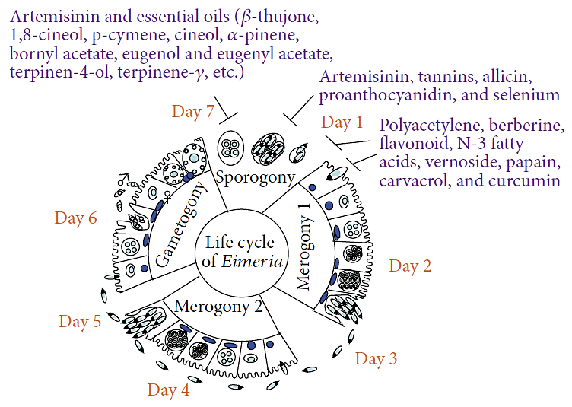
圖二、 影響艾美屬球蟲不同生活史的植化物。
Figure 1. Plant compounds target different stages of the life cycle of Eimeria species.
(Muthamilselvan et al., 2016)
表一、 列舉抗球蟲植物。
Table 1. Anticoccidial properties of plants.
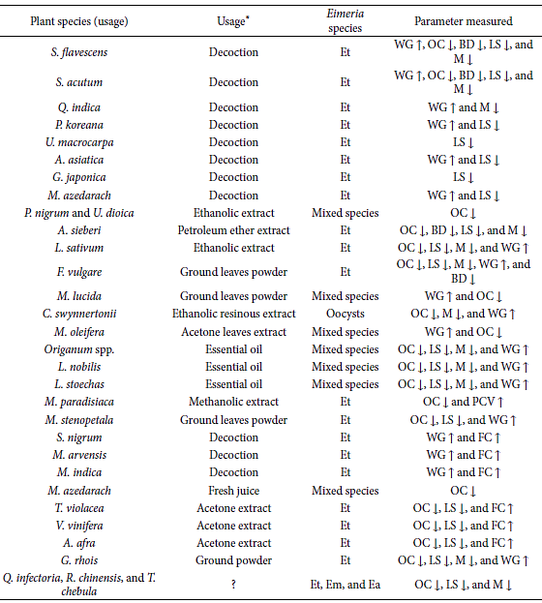
Et: E. tenella; Ea: E. acervulina; Ema: E. maxima; Eb: E. brunetti; En: E. necatrix; Emi: E. mivati; WG: body weight gain; OC: oocyst count; FC: feed consumption; M: mortality; EO: essential oil; BD: bloody diarrhea; FCR: feed conversion ratio; LS: lesion scores; ↑: improvement/increase/higher; ↓: decrease/lower; PCV: packed cell volume; ∗: whole plants and/or aerial parts of plants were used for tests unless indicated otherwise; ?: unknown.
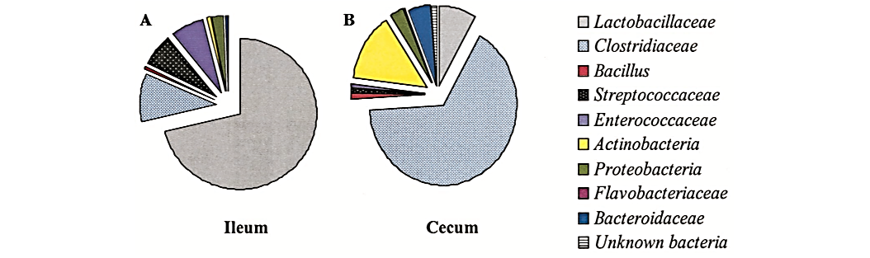
圖四、 (A) 肉雞迴腸菌群組成，(B) 肉雞盲腸菌群組成。
Figure 4. Composition of the bacterial ﬂoras of the ilea and ceca of broiler chickens as determined by sequencing of 1,230 clones from a 16S rDNA community DNA library. (A) Bacterial composition of the ileum. (B) Bacterial composition of the cecum.
(Lu et al., 2003)

表二、在迴腸和盲腸16S rDNA基因庫檢測到之細菌屬
Table 2. Bacterial genera detected in both the ileal and cecal 16S rDNA libraries.
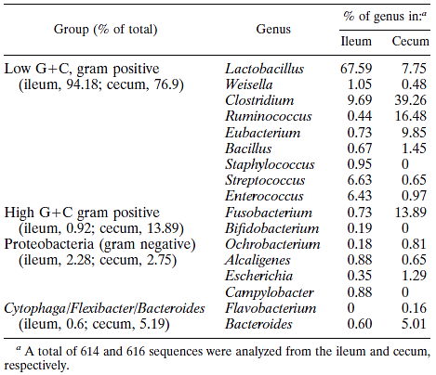
(Lu et al., 2003)

表三、飼糧添加BPCE對感染球蟲白肉雞生長性狀之影響
Table 3. Means¹ of growth performances of broilers fed with different treatment diets with E. tenella infection.
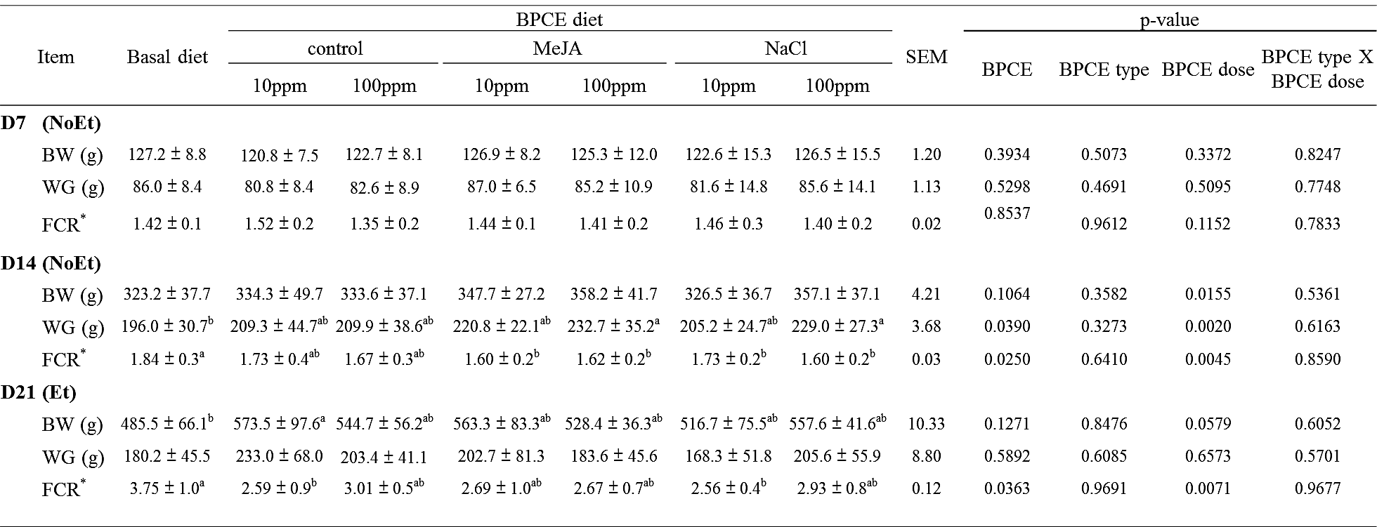
*FCR, feed conversion rate = feed intake / weight gain.
¹Mean ± SD (n = 12-13).
^{ab} Different letters within the same row indicate significant differences among treatment according to Duncan’s multiple range (P < 0.05).
表四、飼糧添加BPCE對白肉雞生長性狀之影響
Table 4. Means¹ of growth performances of broilers fed with different treatment diets without E. tenella infection.
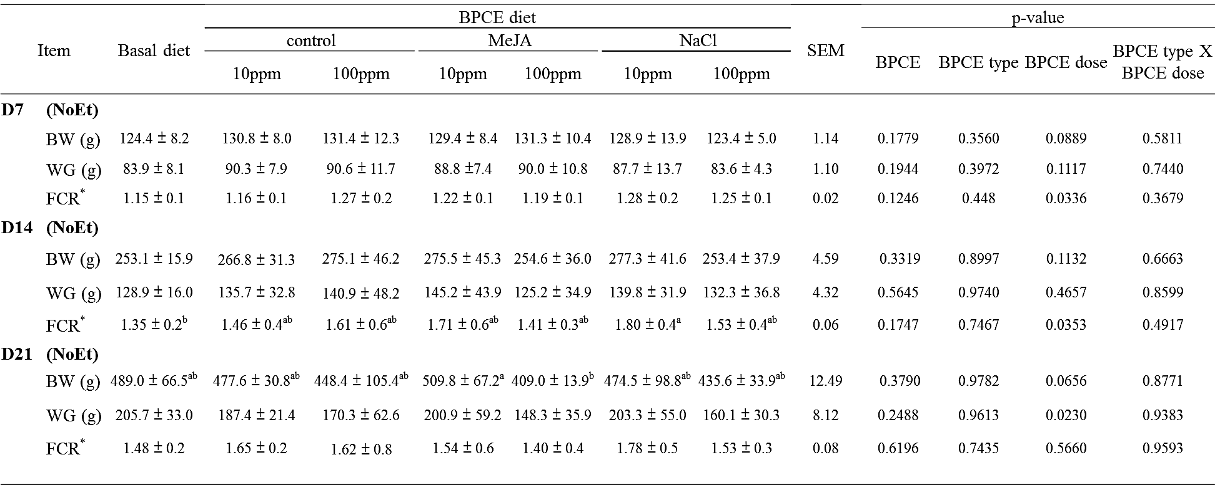
*FCR, feed conversion rate = feed intake / weight gain.
¹Mean ± SD (n = 12-13).
^{ab} Different letters within the same row indicate significant differences among treatment according to Duncan’s multiple range (P < 0.05).
表五、飼糧添加BPCE對白肉雞小腸絨毛性狀之影響
Table 5. Means¹ of morphological measurements of the mid small intestine on different treatments at 21-day of the ages without E. tenella infection.
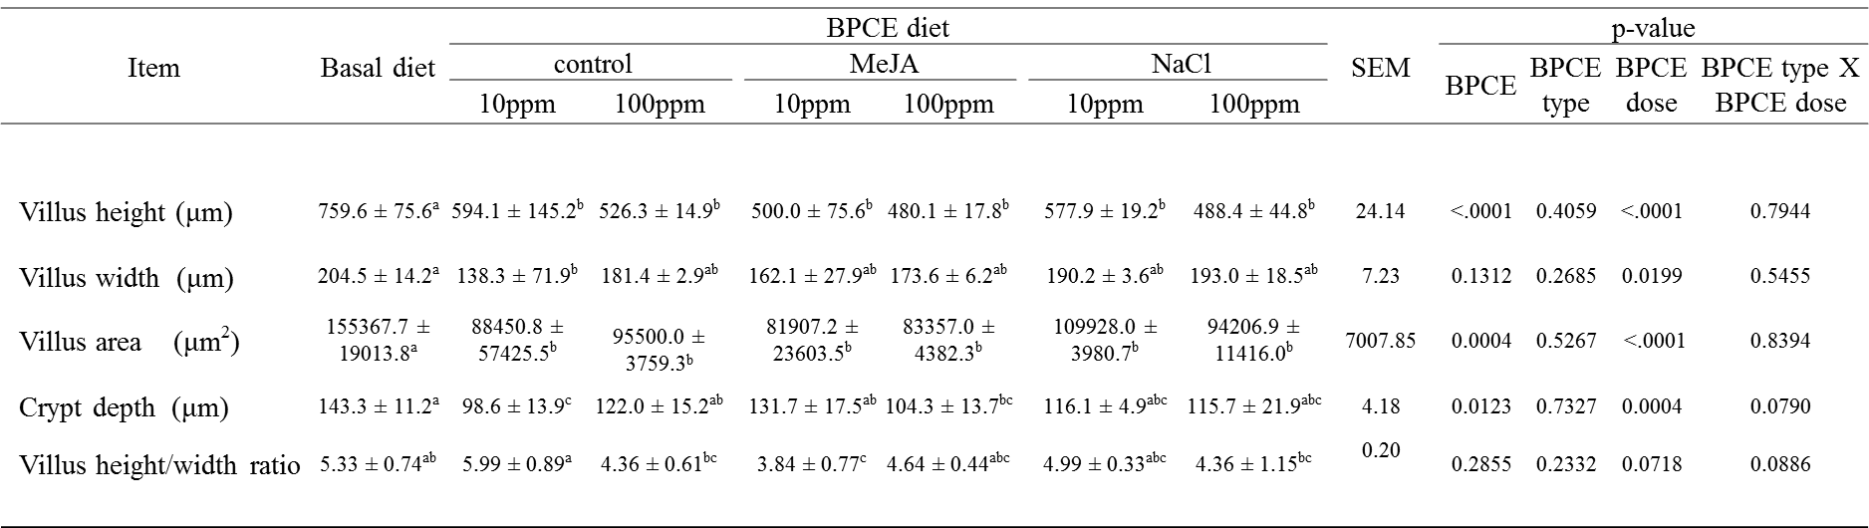
^{a-c} Different letters within the same row indicate significant differences among treatment according to Duncan’s multiple range (P < 0.05). ¹Means ± SD (n=3).

表六、飼糧添加BPCE對感染球蟲白肉雞糞便卵囊數之影響
Table 6. Means¹ of fecal oocysts (oocysts per gram, OPG) shed by birds fed with different treatment diets at post-infection (PI) D5-D7.
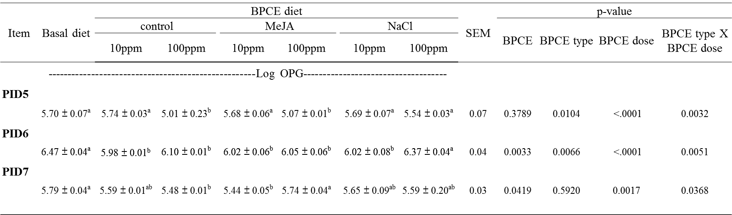
^{ab} Different letters within the same row indicate significant differences among treatment according to Duncan’s multiple range (P < 0.05).
¹Means ± SD.

表七、飼糧添加BPCE對感染球蟲白肉雞盲腸切片病變評分之影響
Table 7. Means¹ of histological parasite score of cecum by birds fed with different treatment diets at post-infection D7.
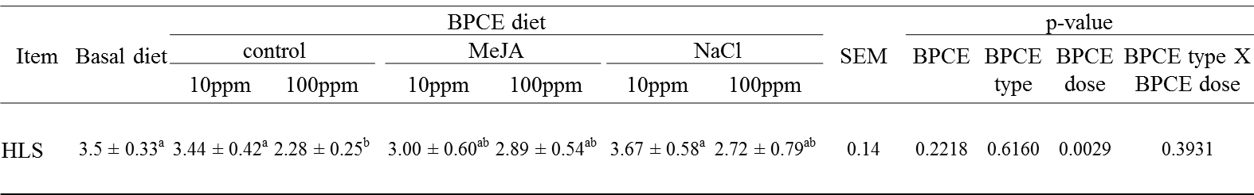
^{ab} Different letters within the same row indicate significant differences among treatment according to Duncan’s multiple range (P < 0.05).
¹Means ± SD (n=3).

圖六、飼糧添加BPCE對感染球蟲白肉雞盲腸切片病變評分之影響
Figure 6. Means¹ of histological parasite score of cecum by birds fed with different treatment diets at post-infection D7.
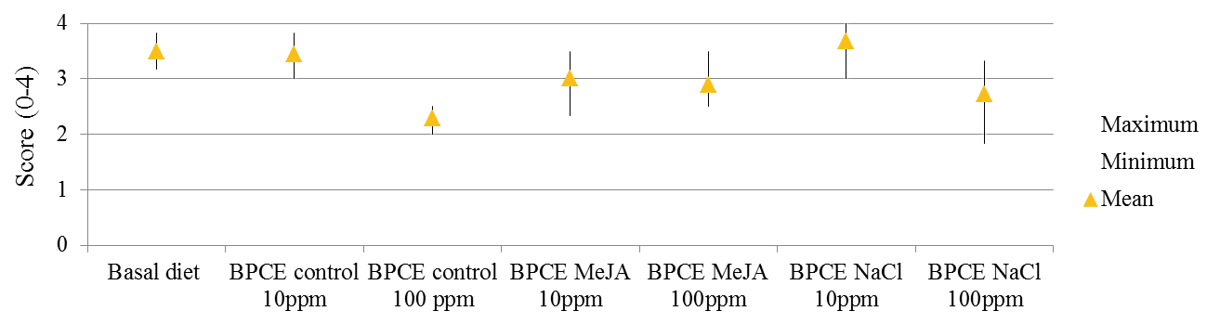

圖七、飼糧添加BPCE對感染球蟲白肉雞盲腸切片觀察
Figure 5. Histological parasite observed in the cecum section and the crypt cells which were highly invaded with the developmental stages of E. tenella schizonts and gametocytes that their morphology is almost disappeared.
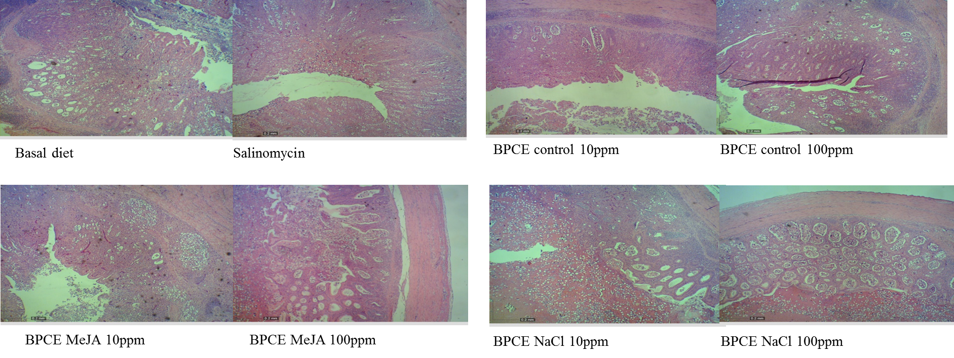

Table 8. Means¹ of gut microflora population (Log CFU/g) of broilers fed with different treatment diets with E. tenella infection.
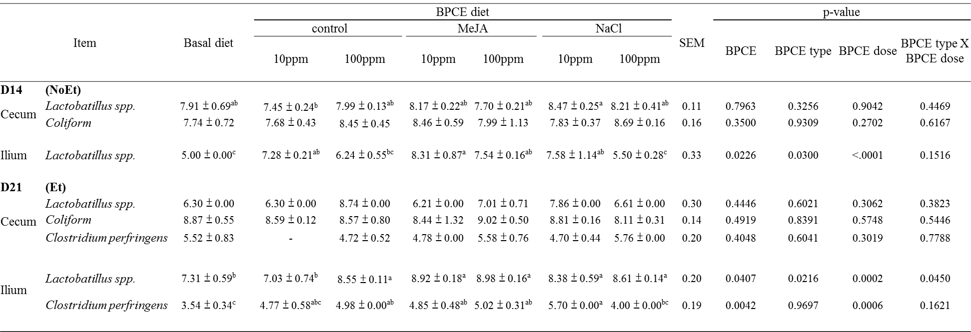
^{a-c} Means within a row with different superscripts are significantly different (p < 0.05)
¹Mean ± SD (n = 2-4).

Table 9. Means¹ of gut microflora population (Log CFU/g) of broilers fed with different treatment diets without E. tenella infection.
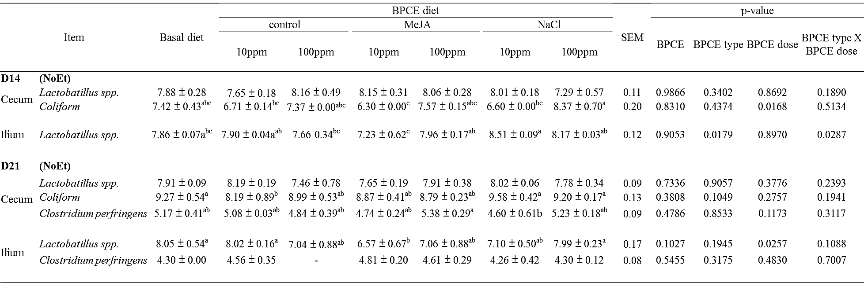
^{a-c} Means within a row with different superscripts are significantly different (p < 0.05)
¹Mean ± SD (n = 2-4).

